The Lightweight IBM Cloud Garage Method for Data Science

Architectural Decisions Document

# Architectural Components Overview

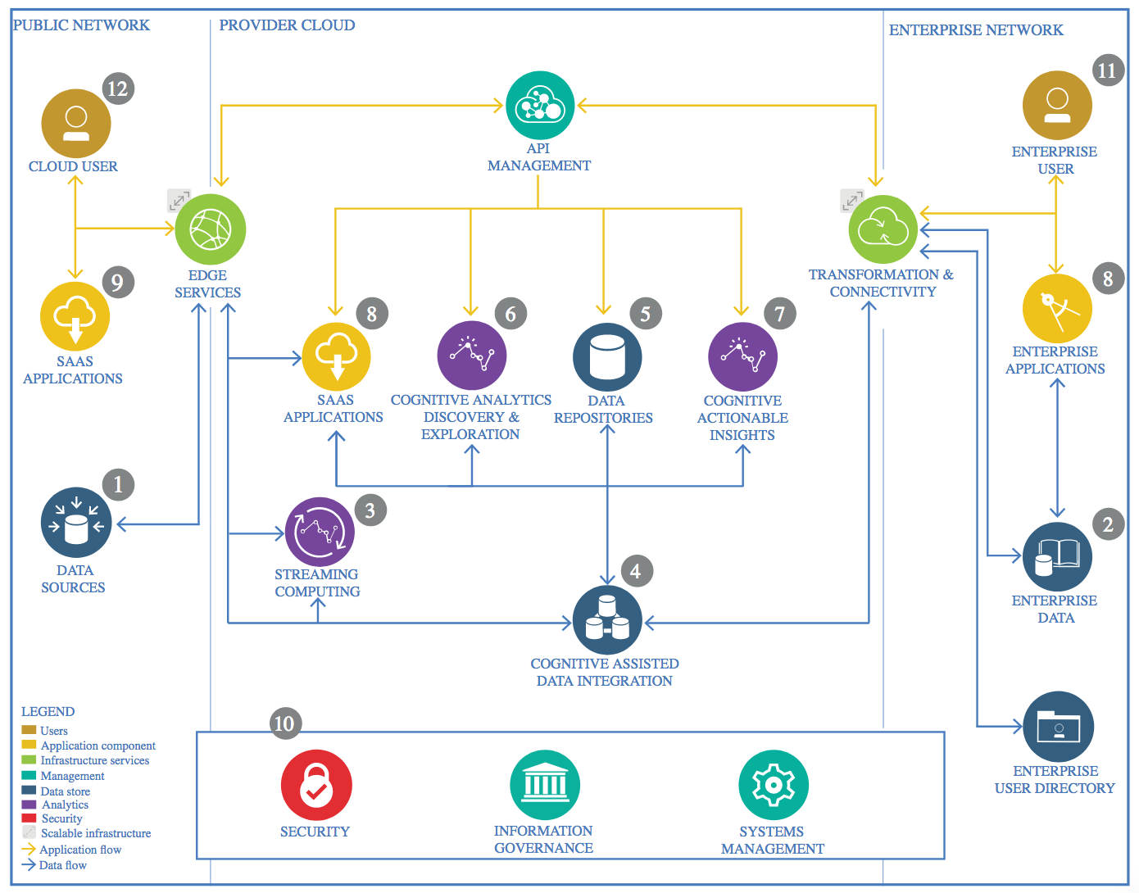

*IBM Data and Analytics Reference Architecture. Source: IBM Corporation*

## Data Source

### Technology Choice

The data source is kaggle where the kaggle API is used to fetch the data. The original file is in csv format. Jupyter notebook is the preferred technology for development. Python pandas and numpy is used to load the data as dataframe and perform data quality checks. Python matplotlib and seaborn are used for visualizations.

### Justification

Jupyter notebook helps the dynamic development and debugging. Given the original file csv format and the size of the file, pandas is the preferred technology. Pandas dataframe is a structured way to load and analyze the data. Numpy is used also for fast array calculations. Matplotlib and seaborn are great tools for pandas dataframes visualizations.

## Enterprise Data

### Technology Choice

Not applicable

### Justification

Enterprise data is not applicable. The data source is kaggle and the dataset is continuously updated. It would make sense to use object storage on the IBM cloud but for the project needs that would be an overhead.

## Streaming analytics

### Technology Choice

The file format is csv with a size of approximately 2MB and therefore for development batch processing is the preferred technology. For production though, real time analytics capabilities would increase the value of the data product, where tweets are classified in real time.

### Justification

Batch processing is the preferred technology because of the file format (CSV) and size (2MB). Online processing and partitioning would be better for larger datasets and other formats.

## Data Integration

### Technology Choice

Please describe what technology you have defined here. Please justify below, why. In case this component is not needed justify below.

### Justification

Please justify your technology choices here.

## Data Repository

### Technology Choice

Please describe what technology you have defined here. Please justify below, why. In case this component is not needed justify below.

### Justification

Please justify your technology choices here.

## Discovery and Exploration

### Technology Choice

Please describe what technology you have defined here. Please justify below, why. In case this component is not needed justify below.

### Justification

Please justify your technology choices here.

## Actionable Insights

### Technology Choice

Please describe what technology you have defined here. Please justify below, why. In case this component is not needed justify below.

### Justification

Please justify your technology choices here.

## Applications / Data Products

### Technology Choice

Please describe what technology you have defined here. Please justify below, why. In case this component is not needed justify below.

### Justification

Please justify your technology choices here.

## Security, Information Governance and Systems Management

### Technology Choice

Please describe what technology you have defined here. Please justify below, why. In case this component is not needed justify below.

### Justification

Please justify your technology choices here.